**Team Members**

**Back ground on team members:-**

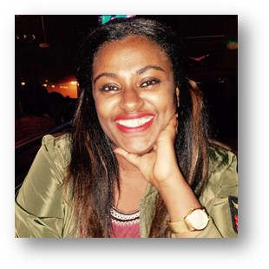Addisalem Berhane, is a young woman working on social transformation and gender equality. After completing her study in sociology she had worked on different capacity on the development sector for eight years. Some of her experience is on managing project on education and maternal health, as programme supervisor on a youth project, teaching in a juvenile delinquency, co-hosting on a radio show that focused on maternal and reproductive health and currently working as a social transformation and gender advisor.

One of her aspiration is to see a world where gender equality is no more an imagination rather a reality. Because the question of gender equality is not a fight between men and women rather a mutually exclusive responsibility. On making sure women are given equal participation in this economy and social justice, she believes it is crucial to think of the underlying causes at the grass root level which is social norms. She believes no matter how much work is done on fighting for poverty challenging social norms that are accommodating the unequal treatment of women is unquestionable

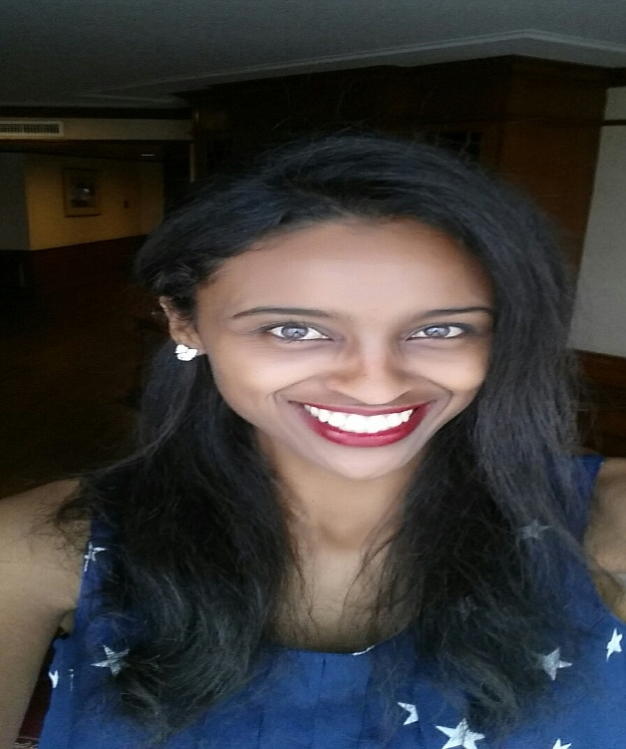Helen Tesfayohannes Hagos is an Advisor on Knowledge management and capacity building for 10 months. General Public Health expertise in Public Health Emergency Management, TB, HIV/AIDS and STI programs for seven years. Investigated outbreaks, assessed hazard, evaluated surveillance system, and conducted meta-analysis and validation study. Managed clinical and supportive staffs of a health center with 36,283 catchment population and 521,000 USD budget. Experienced in public speaking, scientific writing, supervision, provision of feedbacks, strategic planning, report writing, monitoring and evaluation of programs. Led mass vaccination programs with 375,129 catchment population, provided trainings, organized review meetings. Mentored, coached, evaluated and awarded subordinates. Experienced in patient disease investigation and management. Established a new association with potential 10,000 members and a health center. Worked in Public Health Officers Association of Ethiopia for seven years as a board member, finance head, internal auditor and Advisory committee. Goal oriented, committed, hard working, highly organized, multitask person and worked as a team.

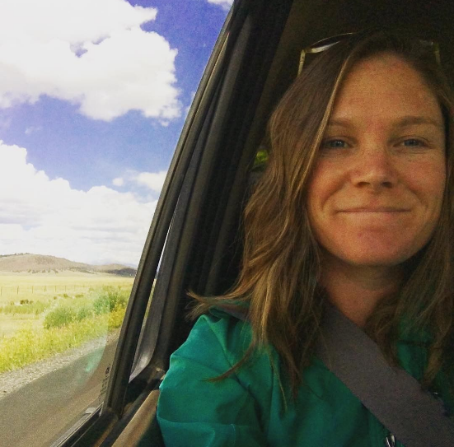Anne Sprinkel isBi-lingual international development and humanitarian aid professional with over 7 years of experience specializing in gender equality, social and behavior change, and gender-based violence. Strong experience leading teams and facilitating critical reflection for strategy development. Professional experience in Nigeria, Mali, Zambia, Ethiopia, Bangladesh, Philippines, India and Guatemala.

**Role of team members:-**

**Addisalem Berhane: -** Addis has a skill on facilitating training on one of CARE’s transformational approach titles Social Analysis and action. It’s an approach that focuses in challenging social norms**.** She has a skill on how to challenge and explore alternatives to transform social norms that are hindering women’s equal participation. As TESFA project mainly focuses on challenging norms her skill on SAA facilitation and exposure to transformational programming will be a great fit. Also as she is based in the programmer quality and learning unit, bing part of such innovation program will pave the way in how to further demonstrate scalable projects and designing models. She will be the main responsible person in running this task.

**Helen Tesfayohannes:-** Helen works as Capacity Building and Knowledge Management part of her responsibility isDevelop Knowledge management strategy for SRHN unit**,** Providing leadership to strengthen the SRHN team through development and strengthening of knowledge management related functions and Organizing exhibition with partner organizations and external stakeholders for the purposes of sharing knowledge and good practices. Helen will be responsible in working with Addis in attending the web ex callas and managing the assignments together.

**Anne Sprinkles:-** is a Technical Advisor, Social & Behavior Change (Sexual & Reproductive Health & Rights Unit) Anne comes with great experience on running projects in the SRHN sector with specialized knowledge on managing the transformation of social behavior and change. Anne was also part of the revisions of the Global SAA manual and developing monitoring and evaluation system for measuring eh changes in social norms and cultures. Anne will be supporting Helen and Addis in write ups, reviewing the validity of information regarding TESFA plus and also aligning upcoming activities to the projects framework.

**Accommodation for participants:-**

The two team captains will require a hotel to stay at, covering for visa cost and ticket. No support required for translation.

**Profile**

*(For a high quality photos, there is a photo voice document)*

**Project objective**

The TESFA approach builds on CARE’s successful Village Savings and Loan Association (VSLA) model by organizing ever-married girls into solidarity-groups through which a 12-month sexual and reproductive health curriculum is delivered, primarily via peers, in addition to the traditional financial literacy training and savings activities. In TESFA, these groups not only provided a forum for economic empowerment (EE) and SRH curriculum, but also a safe place to meet and build a supportive network with other married adolescents. While VSLA has been widely used by both CARE and other partners, this was the first time it was adapted exclusively for ever-married adolescent girls.

The TESFA model also works with community ‘gatekeepers’ (village elders, religious leaders, mothers-in-laws, husbands and health extension workers) who are recruited as a part of Social Action and Analysis (SAA) groups. Through these SAA groups, key influencers in the community become champions of the program and help to create an enabling environment for married adolescent girls to achieve both economic and health outcomes.

**Project description**

TESFA project had different phases. The current TESFA funded by Johnson and Johnson started in 2015. The project year ended in 2017 but another year of learning was added. The project is being implemented in 11 Kebeles of Farta Wereda, South Gonder of Amhara region. The project’s budget for the three years was $950,000USD. The target groups of the project are 2,587 ever-married adolescent girls and 1,440 norm gatekeepers. The project uses Social Analysis and Action approach to challenge harmful social attitudes and norms that negatively impact the lives of adolescent girls. SAA groups undergo critical self-reflection and dialogue on social issues affecting the girls, and engage with the community about the alternatives to early marriage, and improved economic and SRH outcomes for adolescent girls. The work of these groups has led to increased support of adolescent girls, particularly from parents and families. To support the girls economically, the girls are involved in village saving and loans (VSLAs) groups. These groups known as girls groups provided a space for the girls to discuss sexual and reproductive health as well as economic issues. In addition to this, members received training on skills needed to identify and implement income generating activities.

The TESFA evaluation demonstrated that girls’ value and benefited from the social connectivity that the TESFA groups cultivated and the ex-post evaluation identified this as one factor that may have contributed to the model’s sustainability and scale. In fact, the girls have requested further, inter-group connectivity. Our hypothesis is that social capital acts as a kind of social ‘bank’ that is accumulated over time and from which people are drawing in order to take social risks – like delaying childbirth. We think this may therefore be a critical component of the model and leverage for sustainable and scalable change would more inter-connectivity and a larger cohort of social capital for young women allow them to take larger steps towards gender equality?

Girls identified that they would like to tell their stories and experiences from participating in TESFA with other adolescent girls. What if we could develop and test a story-telling campaign that builds the brand of the TESFA model and girls’ connectivity.

We think such an addition may serve to catalyze adoption. This could also serve to shift social and gender norms beyond the TESFA implementation areas, thus amplifying the impact.

We know that girls who have participated in TESFA chose to attend school due to their newfound mobility right and autonomy. What if we could link the TESFA model with the school platform, institutionalizing it and reaching more girls earlier? We seek to explore new avenues and possibly new target groups (unmarried, younger) for the TESFA+

model.

In Ethiopia, CARE found a way to change the bleak reality married girls’ face— **unlocking their power and futures — through the TESFA program**, which means ‘hope’ in Amharic. Through this program **5,000 girls’ lives have been** **transformed**. Four years after this program ended the girls continue to implement the TESFA program on their own and scale it. TESFA model has been implemented for 3 years by CARE and 4 years by girls on their own. We have 7 years of TESFA implementation and user experience under our belts! Time to harness this experience, to **design and test a** **more impactful and scalable version of the TESFA model – TESFA+ –** , bringing its benefits to the millions of married girls around the globe.

**Progress made to date**

**Phase 0:- Start up**

During the start-up phase the team will laid the foundation for the project, including hiring staff and establishing partner contracts. During this phase, CARE will start the process to establish the necessary contract with the government for carrying-out this initiative in its entirety. This can take up to 1 year, which means it will be in place as Phase I draws to a close.

**Phase one: - Formative investigation stage**

Building on the ‘Ex Post Evaluation’, we are currently investigating and identifying the essential components of the TESFA model that have contributed to the self-replication and sustainability we have already observed in Ethiopia. This will also entail learning from our users what they see as the factors facilitating or impeding TESFA sustainability and scale. Recognizing that the young women from the original TESFA groups have over 7 years’ experience participating in TESFA and have already shared ideas and suggestions for how to improve the model.

We are harnessing their and other key stakeholders’ suggestions for enhancing the model and also understanding additional avenues and partnerships for multiplying the impact of the TESFA model. The formative phase is focusing on our experience and users to identify the critical elements and facilitators for replication as well enhancements and new innovations to prototype for arriving at a more impactful and scalable, redesigned version.

Currently the progress made is Exploration & documentation of:

1) Barriers & facilitators of TESFA model scale, incl. self-replication;

2) Users’ suggestions & ideas on improving the TESFA model & scaling it; and

3) Avenues for multiplying the impact of the TESFA model

**Accelerator outcomes**

* Identified an effective, scalable TESFA+ model
* Increased understanding among stakeholders about the TESFA+ model
* To improve the lives of married and unmarried adolescent girls across Ethiopia and beyond

**Moving forward**

**Phase II: Design Model**

Next, we will draw on the insights gathered during Phase I to redesign the TESFA model, with the aim of pro-actively encouraging scale and creating a more impactful model. This may include: modifying existing elements to amplify successful components or prototyping new ‘innovations’ or ‘enhancements’ that we think will powerfully contribute to scaling the model, such story-telling or inter-group connectivity components. In holding to design-thinking principles, we will carry out the design process in partnership with original TESFA participants and stakeholders, such as government, UN officials and possibly relevant national groups who have shared interests (i.e. Setaweet or the National Women’s Business Association). CARE may partner with a design consultant to layout and co-facilitate the process. At the close of this phase we aim to have co-created a cutting edge TESFA+ model ready for testing.

**Phase III: Implementation and Testing Planning**

As the model is not pre-determined and will be designed during design model , we will need to plan for the model implementation and testing. This will likely include developing more detailed TESFA+ model theory of change, implementation and evaluation plans, revisiting budgets, and bringing on additional implementation and evaluation partners as needed. Further, as sharing of our lessons and evidence will be integral to diffusing the TESFA+ model and increasing understanding among stakeholders (e.g. governments, donors and adolescent sexual reproductive health practitioners) about scaling, our planning will include mapping of audiences and forums for sharing and developing a dissemination plan. The related activities would then be carried-out during implementation and testing phase.

**Phase IV: Model Implementation and Testing**

This phase will be iterative and will include a strong implementation learning component as we roll-out the model. This phase may also include prototyping and further design exploration of add-o components. While the implementation and evaluation plans can, in large part, only be determined after the model is defined we anticipate the evaluation will provide proof of effectiveness – both evidence on if the TESFA+ model scales; as well as if it impacted key sexual and reproductive health and empowerment outcomes.

1. Background document (we can share them the photo voice, evaluation report of the current TESFA)

Multiple factors make adolescent girls disproportionately vulnerable to poverty and marginalization in Ethiopia. They face a range of discriminatory socio-cultural norms, are exposed to a high incidence rate of gender-based violence, and have little or no support from government policies and systems. The vulnerabilities are greatest for girls who have little to no education, live in rural areas and have low incomes. In addition, being a married adolescent girl equates to social isolation, low levels of confidence and self-efficacy, barriers to education, minimal to no access or control over income or other assets, financial dependency on a husband, intimate partner violence, and social pressure to bear children.

The Amhara region of Ethiopia has one of the highest rates of early and forced marriages in the country. It is reported that as many as 48 percent of girls are married off by the age of 15, with serious consequences for the lives of these adolescent girls, particularly with respect to sexual and reproductive health, education, and economic stability. Towards Improved Economic and Sexual Reproductive Health Outcomes for Adolescent Girls (TESFA2 ), funded by Johnson & Johnson since 2015, specifically addresses the economic and sexual and reproductive health problems of ever-married girls. CARE has years of experience working with these girls through

Various interventions.

1. Background document (can we share the full proposal?)

Attached is the TESFA+ proposal, it’s rather short but it does give a good background

1. Have you already started the process of scaling up?

To scale up the project, a new another project has been started. The project is in the phase of formative research on 2018 and on the implementation phase in the coming years. We’ve tested the model and scaled it horizontally in the original program area, doubling the original reach of the program (over the course of the past 7 years). To build on an ex-post evaluation of the original program, research on the facilitators and barriers to additional forms of scaling (vertical and spontaneous) is underway.

1. What are your team goals for scaling?

TESFA+ will be a model that is impactful and successfully scaled not only in Ethiopia but 7 other countries while also providing guidance for CARE’s adolescent sexual reproductive health portfolio.

1. Five years from now, how far do you expect scaling up to have progressed?

TESFA+ scalable will be piloted through 2.5 years of implementation, rigorously evaluated, and adapted and scaled in 7 other countries.

1. In the application, we asked about the biggest barrier to scale. Are there additional barriers we should be thinking about?

Certain components of the TESFA model, namely Social Analysis & Action, require not only dedicated staff time but also skills that are not commonly found nor promoted within potential end-users if pursuing vertical scale. Similarly, building these skills within communities is very possible and very effective but requires investment. Furthermore, the empowerment of a marginalized group in conjunction with their communities, in part through exercising collective efficacy, may be in direct contradiction to the motivations of the government if not handled and communicated properly.

1. If your team could prioritize learning new information or a new set of skills that would help you take the innovation to scale, what would it be?

I don’t know about you, but I can’t decide – new information about scaling norms-focused programming doesn’t REALLY exist in many places yet; New set of skills for forming government partnerships and/or helping prepare government to become a successful end-user is also needed.

1. If your team had access to a mentor that would support you on a particular issue, what would that issue be and what knowledge, skills or connections would that mentor have? How to get governments like the one in Ethiopia to shift resources (financial, people) in order to prioritize most marginalized populations with interventions that are new to them.
2. If your team had access to consultant or vendor support, what would you hire that consultant to do?

To help us design a model? We already have the TESFA model, but that model needs to be adapted to scale. We have consultants doing the research to see the facilitators and barriers to scale, but a consultant to help in the co-design phase (Phase II) would be helpful – so working with both govt partners and communities to adapt the current model using our research findings.